Bigdata Assignment 5.4

Create a calculator to work with rational numbers.

Requirements:

○ It should provide capability to add, subtract, divide and multiply rational

numbers

○ Create a method to compute GCD (this will come in handy during operations on

rational)

Add option to work with whole numbers which are also rational numbers i.e. (n/1)

- achieve the above using auxiliary constructors

- enable method overloading to enable each function to work with numbers and rational.

Solution -

**object Rationals {**

**def main(args: Array[String]) {**

**// We are passing numbers to Rational Class for three cases when two nos are integers , two nos are rationals and one is rational and the other is integer.**

**/*var a = new Rational(4,3)**

**var b = new Rational(10,7)**

**var a = new Rational(4,2)**

**var b = new Rational(10,5)*/**

**var a = new Rational(10,3)**

**var b = new Rational(6,3)**

**// Get the Result**

**var result = a+b**

**// Print the Result - don't print the denominator if it is 1**

**if (result.denom==1) println("Result of " + a.numer + " + "+b.numer+" is :"+result.numer)**

**else if (a.denom!=1 && b.denom!=1)println("Result of "+a.numer+"/"+a.denom+" + "+ b.numer +"/"+b.denom+" is: " + result.numer + "/" + result.denom)**

**else if (a.denom==1 && b.denom!=1)println("Result of "+a.numer+"+"+b.numer+"/"+b.denom+" is: " + result.numer + "/" + result.denom)**

**else println("Result of "+a.numer+"/"+a.denom+" + "+ b.numer + "is: " + result.numer + "/" + result.denom)**

**}**

**}**

**class Rational(n: Int, d: Int) {**

**//GCD method**

**private def gcd(x: Int, y: Int): Int = {**

**if (x == 0) y**

**else if (x < 0) gcd(-x, y)**

**else if (y < 0) -gcd(x, -y)**

**else gcd(y % x, x)**

**}**

**//Auxillary Constructor**

**def this(x:Int){**

**this(x,1)**

**}**

**private val g = gcd(n, d)**

**val numer: Int = n/g**

**val denom: Int = d/g**

**//Method Overloading for each type of operation**

**//Addition**

**def +(that: Rational) = new Rational(numer*that.denom + that.numer*denom,denom*that.denom)**

**//Subtraction**

**def -(that: Rational) = new Rational(numer*that.denom - that.numer*denom,denom*that.denom)**

**//Multiplication**

**def *(that: Rational) = new Rational(numer*that.numer, denom*that.denom)**

**//Division**

**def /(that: Rational) = new Rational(numer*that.denom, denom*that.numer)**

**}**

**Output -**

Here input was 2 rational no(4/3 and 10/7) and we performed addition.

The result was 58/21.

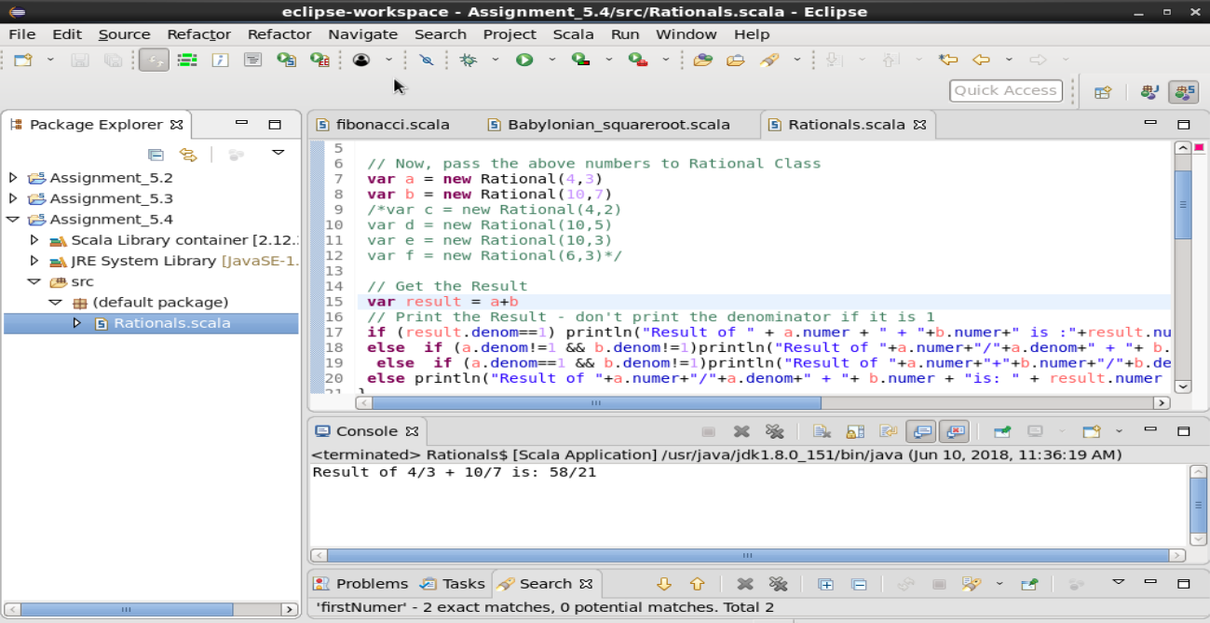

Here input was 2 integers(2 aand 2) and performed addition , we got the output as 4.

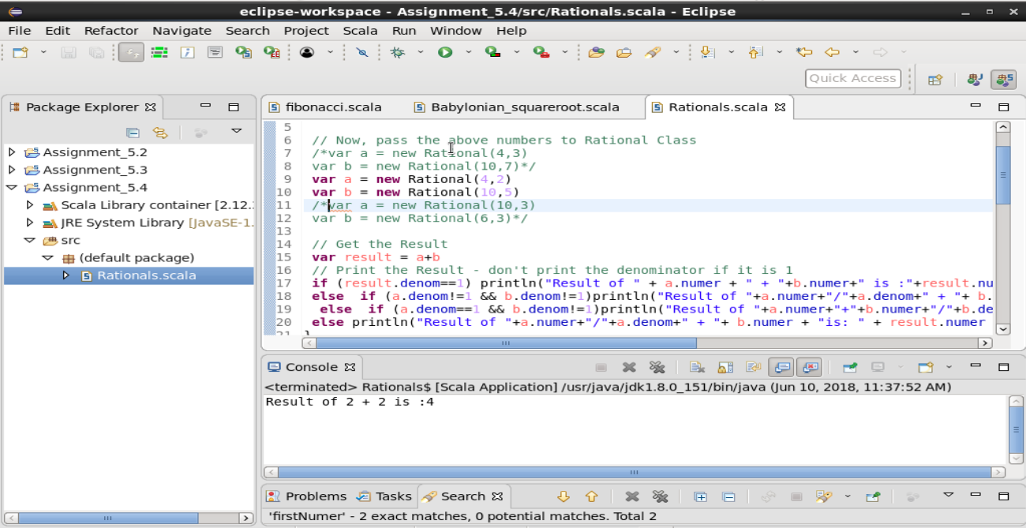

Here the input is one integer 2 and one rational 10/3 , we performed addition and we got the result as 16/3.

